

Use this two-part process to **cancel** the **Final Claim** and prepare a new Final Claim for billing. In the first part, you will **cancel** the claim, which will reset charges in your AR to zero. If you plan to bill the episode, part two recreates the EOE Event, which allows final billing to occur.   
  
Typically, the EOE Event is created when you perform a claims audit in workflow manager; however, there is not a Perform Claims Audit workflow task created for manually **cancelled** claims, so you must recreate the EOE Event manually.  
  
**Part I – Cancel the final claim**  
1.     On the Financial Manager workspace, click PPS Billing > Episode Management.  
2.     Under Episode Dates, choose No Date.  
3.     Select Episode and type in the patient’s last name.  There may be multiple episodes for a patient.  Be sure to select the correct one.  
4.     Double-click the episode to **cancel**.  
5.     Under Episode Events, select **Cancel** Claim.

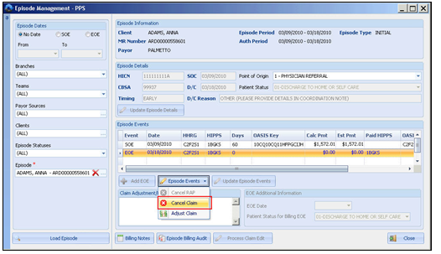  
  
6.     On the Final Claim **Cancellation** dialog,  
     a.     For Internal Control, specify the number provided by your payor when the claim was processed. If you did not receive a payment for the episode, enter NA or CORRECTION.  
     b.     For Condition Codes, check the applicable code for **canceling** the claim.  
     c.     For Comments, specify remarks as needed.  
     d.     Click Save.

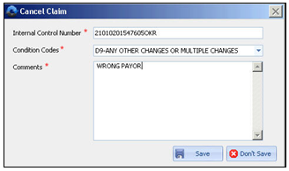  
  
7.     Click Close on the Episode Management screen.  
  
**Cancellation** claims are not available for electronic submission. If you submitted the Final Claim to the payor and received payment, you must manually **cancel** the Final Claim on your payors data entry system.

**Part II - Prepare a new Final Claim from a previously cancelled episode (Final Claim)**  
If you do not plan on billing this episode, you can skip this procedure and inactivate the PPS payor source in the patient’s record.

If you plan to bill this episode to another payor, you will need to complete a Payor Change before completing Part II (see lesson on Changing Payors in the Advanced Billing and AR training manual).  
1.     Return to Episode Management and load the episode for the patient.  
2.     Under EOE Additional Information, enter EOE Date and Patient Status for Billing EOE.  
3.     Click Add EOE.

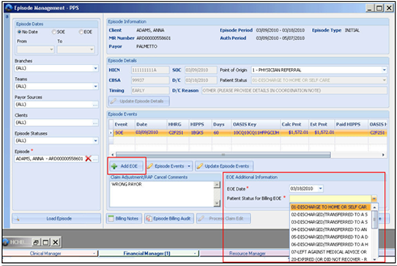

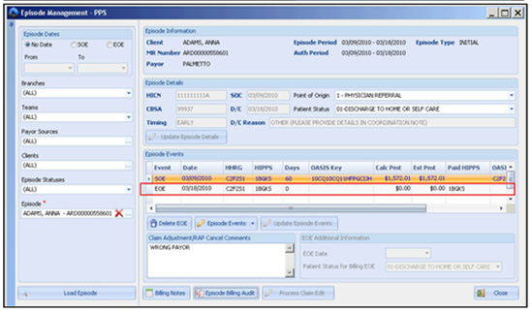  
4.     Click Close.  
5.     Return to the Financial Manager workspace.  
  
You can now generate a new **RAP** and Final Claim for this episode